MOSES LISTENS TO GOD IN THE BURNING BUSH
Exodus 3-4

MAIN POINT: We can encounter God anytime anywhere.

KEY VERSE: ‘The Lord said to him, “Who makes a man able to talk? Who makes him unable to hear or speak? Who makes him able to see? Who makes him blind? It is I, the Lord. Now go. I will help you speak. I will teach you what to say.” Exodus 4:11-12

Craft Ideas

Moses Listens to God in the Burning Bush Craft

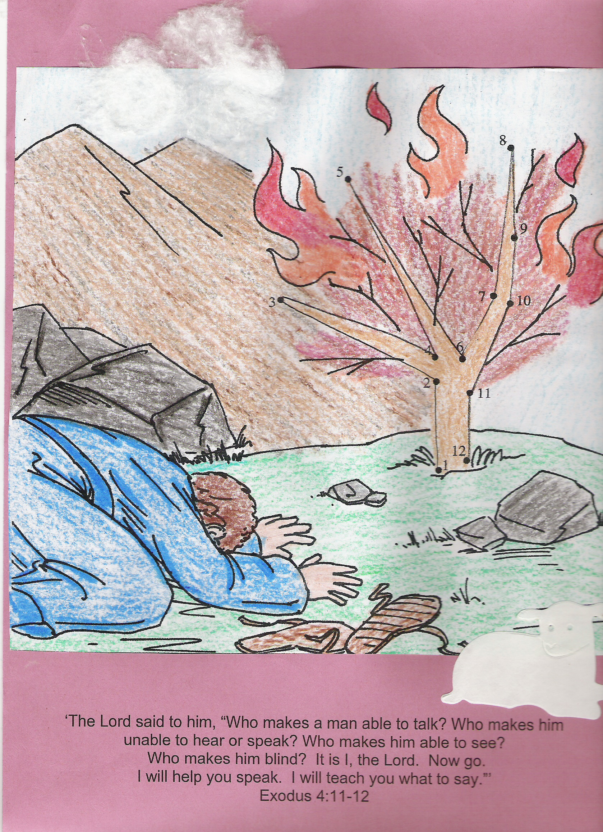

Craft Supplies: copy of coloring page, cardstock, lamb sticker or die cut, crayons, glue sticks, cotton balls

- Copy coloring page.
- Print Exodus 4:11-12 on bottom of page. Copy onto cardstock, loaded in bypass tray of copy machine or write the verse on the cardstock or construction paper.
- Color the Burning Bush picture and glue to cardstock using a glue stick.
- Add cotton balls and lamb.

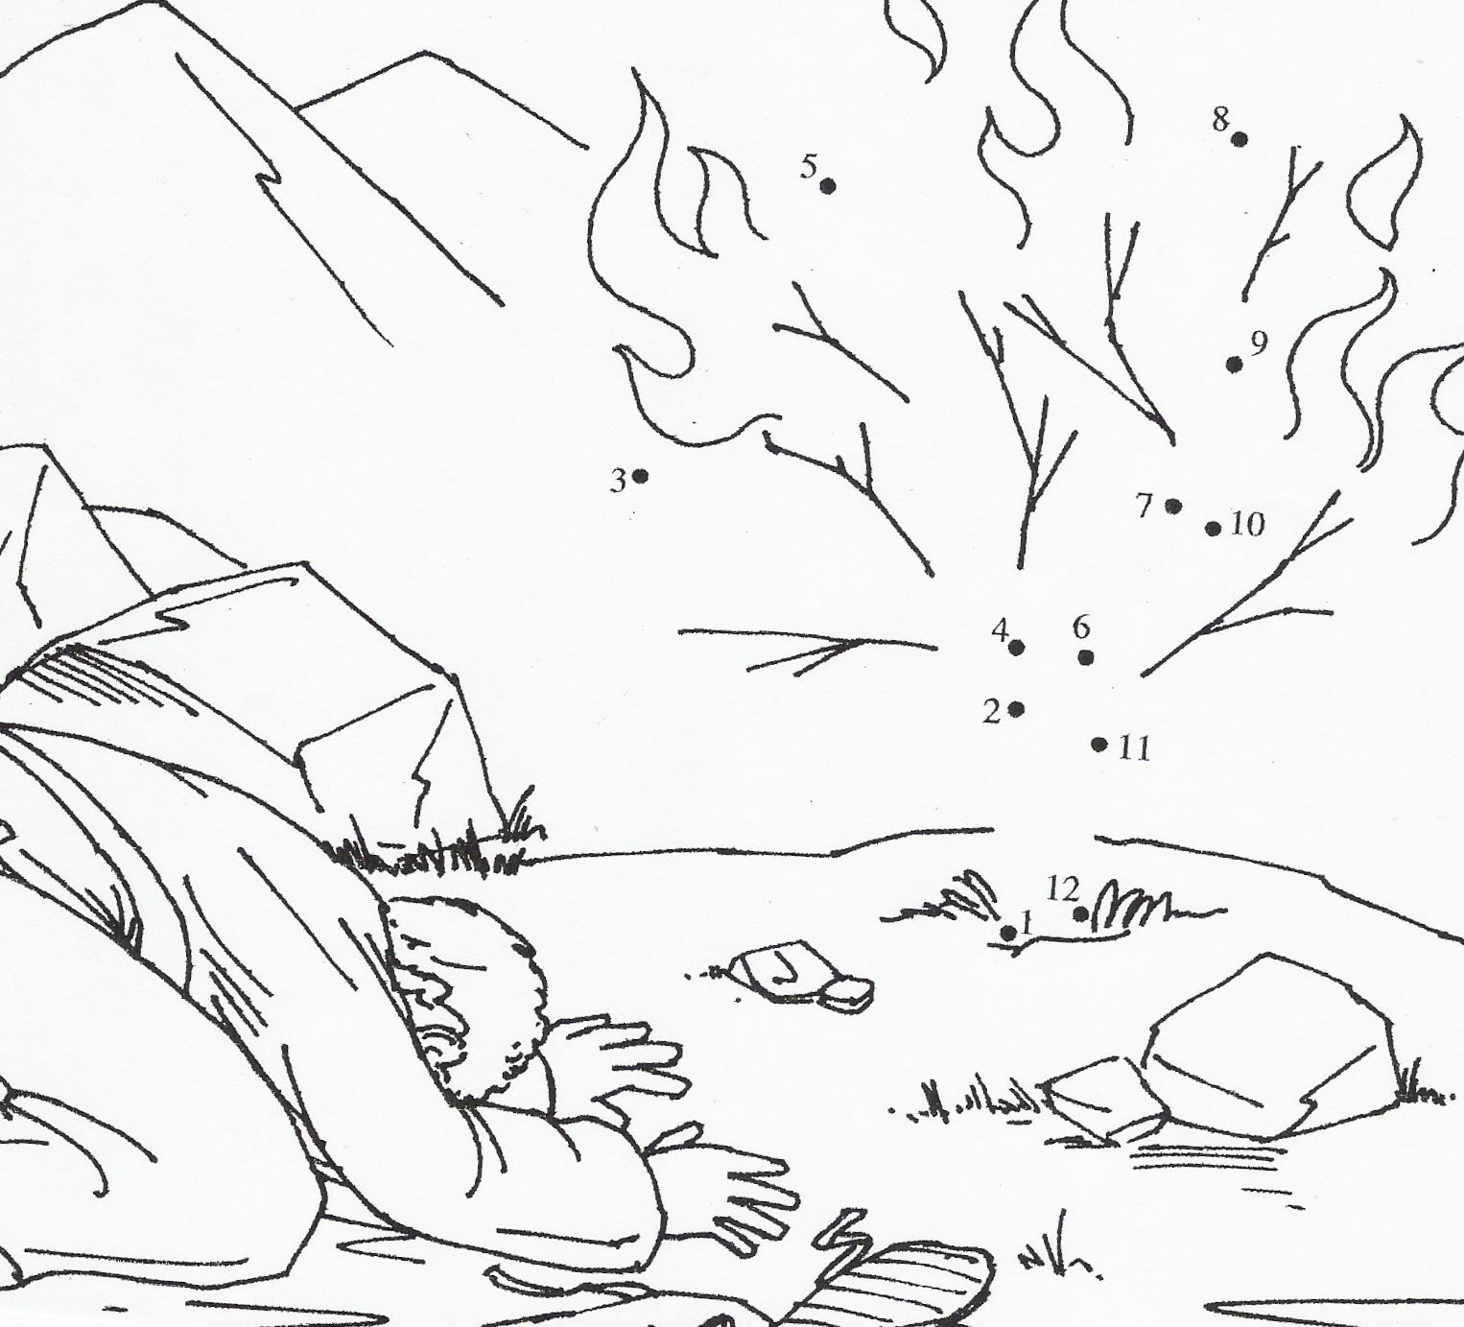

Footprints in the Sand, (www.guildcraftinc.com)
- Decorate “footprint” with markers.
- Glue poem to craft.
- Glue shells to craft.
- Add Key Verse sticker to back of Footprint.


